**Assignment 3**

Name : Priya Chougale

Roll No.: 323012

PRN : 22011171

**Title:** Deploy Web application on Microsoft Azure (PHP/Python/Node js any application)

**Theory:**

**1) Cloud Computing Definition.**

Cloud Computing is the use of off-site systems to help computers store, manage, process, and/or communicate information. These off-site systems are hosted on the cloud (or the internet) instead of on your computer or other local storage. They can encompass anything from email servers to software programs, data storage, or even increasing your computer’s processing power.

The “cloud” is a term that simply means “the internet.” Computing involves the infrastructures and systems that allow a computer to run and build, deploy, or interact with information. In cloud computing, this means that instead of hosting infrastructure, systems, or applications on your hard drive or an on-site server, you’re hosting it on virtual/online servers that connect to your computer through secure networks.

**2) Cloud Service models and Deployment models**

Cloud computing can be separated into three general service delivery categories or forms of cloud computing:

1. **IaaS.** IaaS providers, such as Amazon Web Services (AWS), supply a virtual server instance and storage, as well as application programming interfaces (APIs) that let users migrate workloads to a virtual machine (VM). Users have an allocated storage capacity and can start, stop, access and configure the VM and storage as desired. IaaS providers offer small, medium, large, extra-large, and memory- or compute-optimized instances, in addition to enabling customization of instances, for various workload needs. The IaaS cloud model is closest to a remote data center for business users.
2. **PaaS.** In the PaaS model, cloud providers host development tools on their infrastructures. Users access these tools over the internet using APIs, web portals or gateway software. PaaS is used for general software development, and many PaaS providers host the software after it's developed. Common PaaS products include Salesforce's Lightning Platform, AWS Elastic Beanstalk and Google App Engine.
3. **SaaS.** SaaS is a distribution model that delivers software applications over the internet; these applications are often called *web services*. Users can access SaaS applications and services from any location using a computer or mobile device that has internet access. In the SaaS model, users gain access to application software and databases. One common example of a SaaS application is Microsoft 365 for productivity and email services.

**Cloud computing deployment models**

1. **Private Cloud:** Private cloud services are delivered from a business's data center to internal users. With a private cloud, an organization builds and maintains its own underlying cloud infrastructure. This model offers the versatility and convenience of the cloud, while preserving the management, control and security common to local data centers. Internal users might or might not be billed for services through IT chargeback. Common private cloud technologies and vendors include VMware and OpenStack.
2. **Public Cloud:** In the public cloud model, a third-party cloud service provider (CSP) delivers the cloud service over the internet. Public cloud services are sold on demand, typically by the minute or hour, though long-term commitments are available for many services. Customers only pay for the central processing unit cycles, storage or bandwidth they consume. Leading public CSPs include AWS, Microsoft Azure, IBM and Google Cloud Platform (GCP), as well as IBM, Oracle and Tencent.
3. **Hybrid Cloud:** A hybrid cloud is a combination of public cloud services and an on-premises private cloud, with orchestration and automation between the two. Companies can run mission-critical workloads or sensitive applications on the private cloud and use the public cloud to handle workload bursts or spikes in demand. The goal of a hybrid cloud is to create a unified, automated, scalable environment that takes advantage of all that a public cloud infrastructure can provide, while still maintaining control over mission-critical data.
4. **Multi-cloud:** In addition, organizations are increasingly embracing a multi-cloud model, or the use of multiple IaaS providers. This enables applications to migrate between different cloud providers or to even operate concurrently across two or more cloud providers. Organizations adopt multi-cloud for various reasons. For example, they could do so to minimize the risk of a cloud service outage or to take advantage of more competitive pricing from a particular provider. Multi-cloud implementation and application development can be a challenge because of the differences between cloud providers' services and APIs.Multi-cloud deployments should become easier, however, as providers' services and APIs converge and become more standardized through industry initiatives such as the Open Cloud Computing Interface.
5. **Community Cloud:** A community cloud, which is shared by several organizations, supports a particular community that shares the same concerns -- e.g., the same mission, policy, security requirements and compliance considerations. A community cloud is either managed by these organizations or a third-party vendor and can be on or off premises.

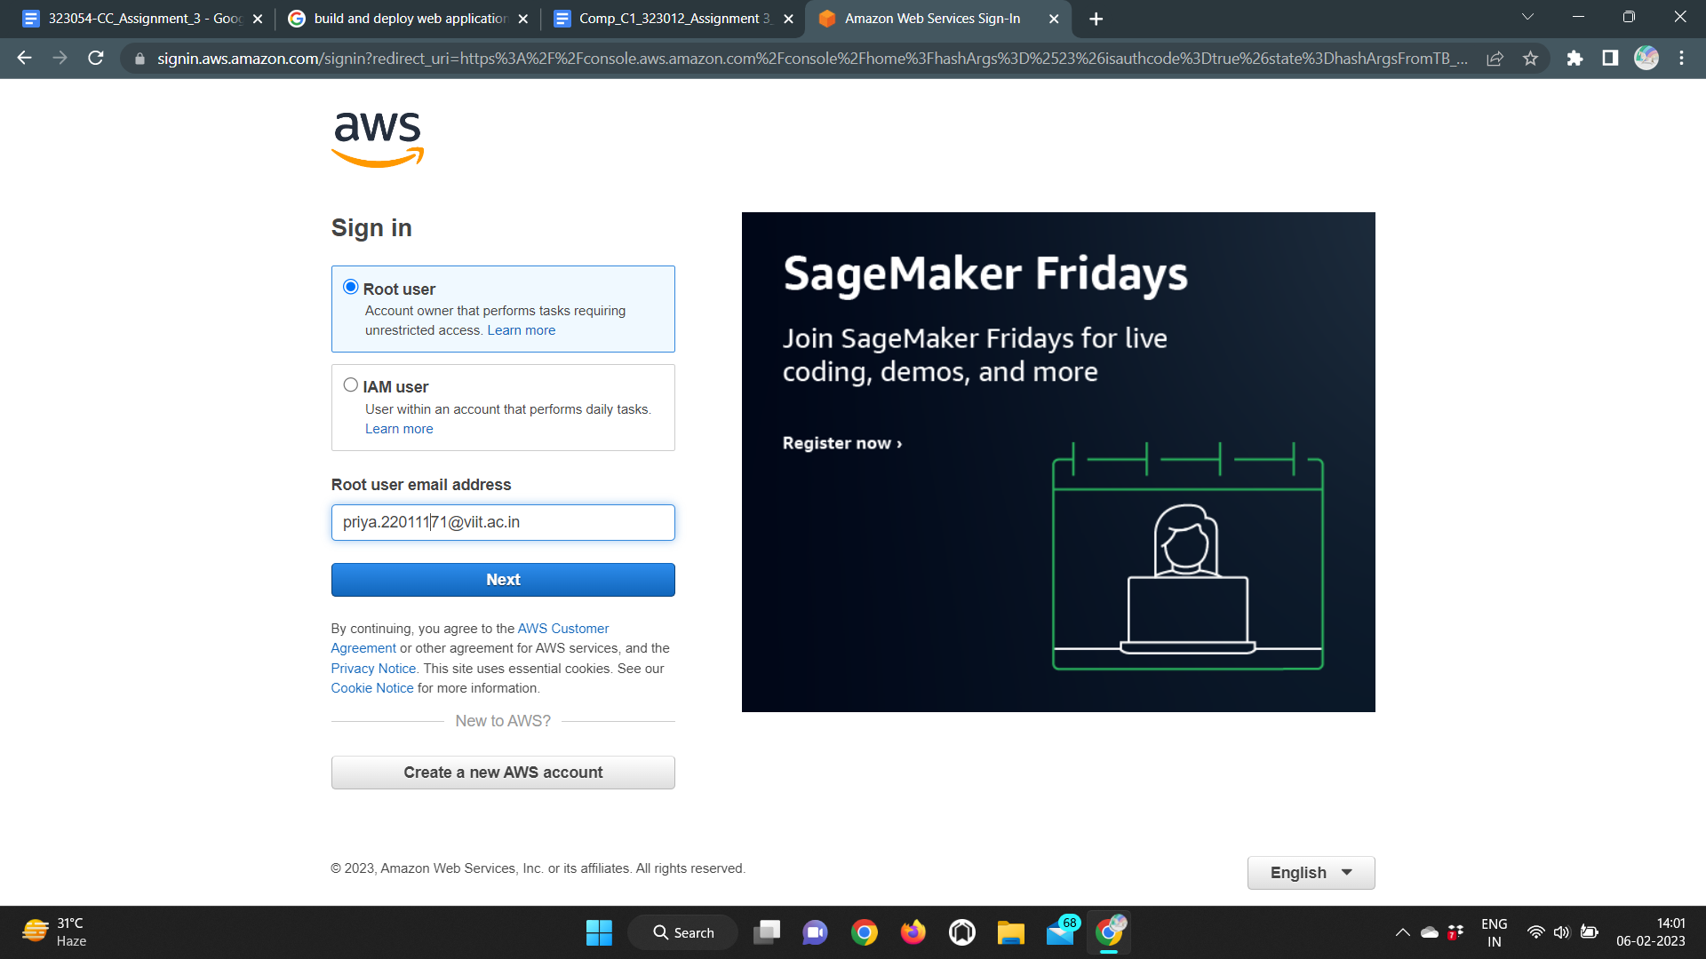

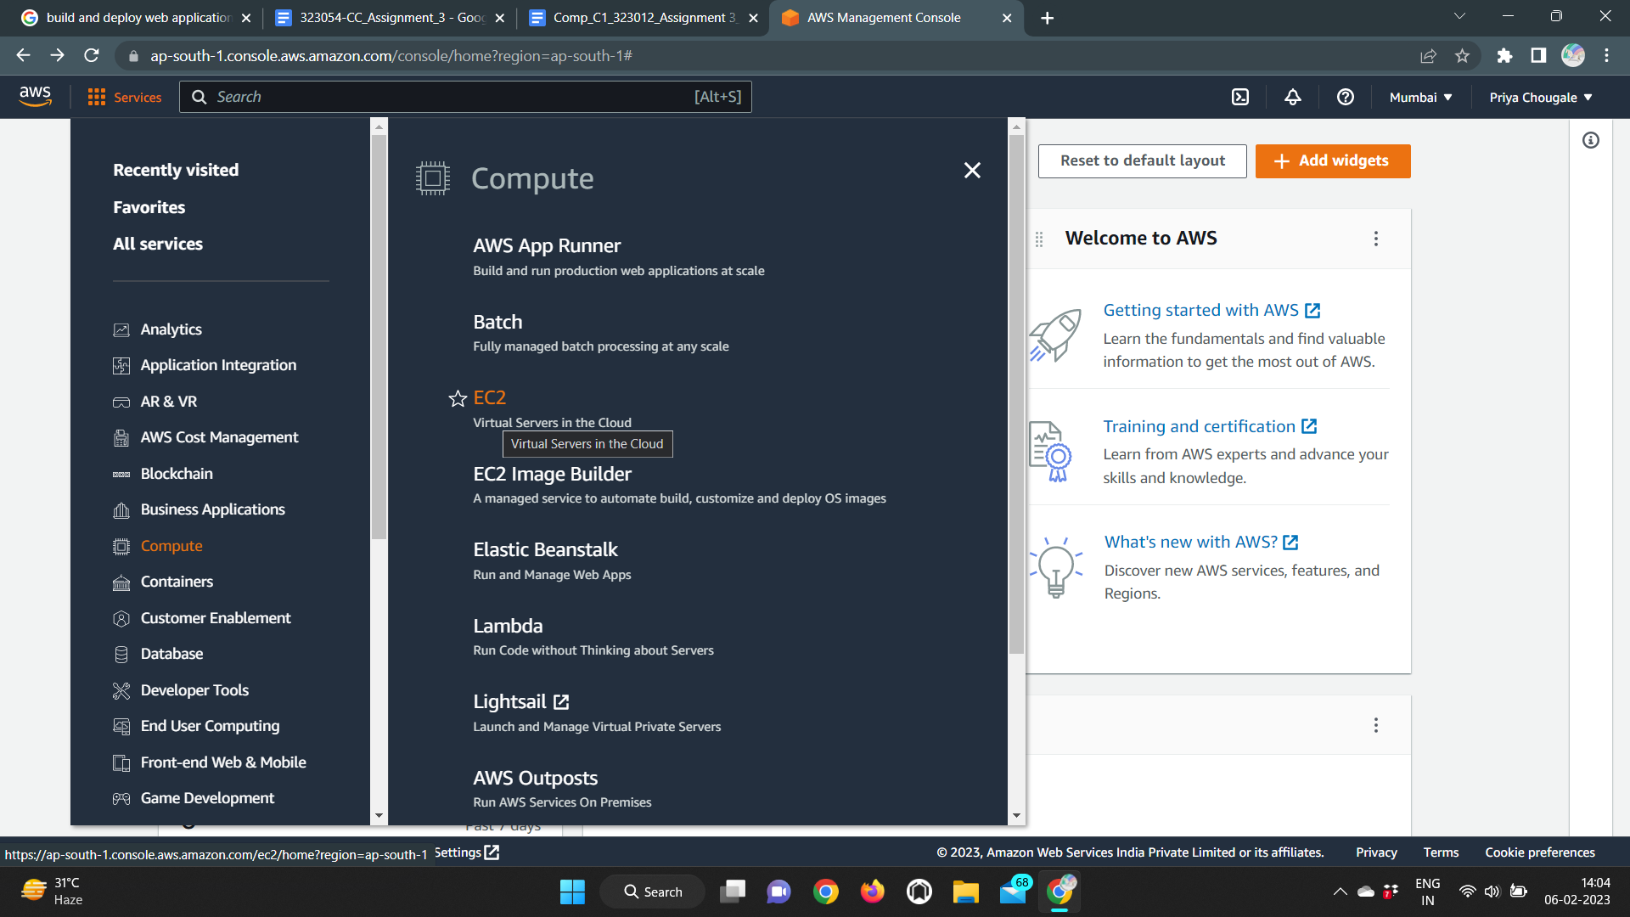

**→ Launch an instance**

